The Characteristics of the Bride of Christ
- Characteristics of the Bride
Song of Solomon 1:9
I have compared thee, O my love, to a company of horses in Pharaoh's chariots.
I have compared thee, O my love, to a company of horses in Pharaoh's chariots.
“I have compared thee”
The Lord reveals His view of the bride’s standings with Him.

The simple instructions and striking illustrations are declared to be the character of the one He is in love with.
“compared” … “to a company of horses in Pharaoh's chariots”

“Company of Horses” – beauty, Excellency, power, stamina, speed, militant, communication, honor, loyalty, military preparedness, freedom, spirit, adventure, peserverance, and drive.
Horses are gentle, loyal, fierce friends and the ultimate travel companions who are willing to go the distance with you.
He compares her to the strong and stately horses in Pharaoh's chariots. Egypt had the best horses. Solomon got his horses from Pharaoh.
“O my love”
The bride “O my love” is revealed by comparing her characteristics “to a company of horses in Pharaoh’s chariots” The purpose of the comparison is to emphasize the superior excellence of the character of the bride of Christ.

We are to be compared only by Him and with His understanding.

Isa 40:18 To whom then will ye liken God? or what likeness will ye compare unto him?
Isa 46:5 To whom will ye liken me, and make me equal, and compare me, that we may be like? Mr 4:30 And he said, Whereunto shall we liken the kingdom of God? or with what comparison shall we compare it?
2Cor. 10:12 For we dare not make ourselves of the number, or compare ourselves with some that commend themselves: but they measuring themselves by themselves, and comparing themselves among themselves, are not wise.
The Lord gives simple instructions and striking illustrations, lessons we all should follow prayerfully.
Malachi 1:2 I have loved you, saith the LORD. Yet ye say, Wherein hast thou loved us? Was not Esau Jacob's brother? saith the LORD: yet I loved Jacob, 3 And I hated Esau, and laid his mountains and his heritage waste for the dragons of the wilderness.

2Cor. 2:8 Wherefore I beseech you that ye would confirm your love toward him.
8:7 Therefore, as ye abound in every thing, in faith, and utterance, and knowledge, and in all diligence, and in your love to us, see that ye abound in this grace also.
8 I speak not by commandment, but by occasion of the forwardness of others, and to prove the sincerity of your love.
24 Wherefore shew ye to them, and before the churches, the proof of your love, and of our boasting on your behalf.
Php 1:9 And this I pray, that your love may abound yet more and more in knowledge and in all judgment;
Col 1:8 Who also declared unto us your love in the Spirit.

The Characteristics of the bride abound as she abides and abounds in His love.
Song 1:9 I have compared thee, O my love, to a company of horses in Pharaoh's chariots.
We are spirits not animals but we learn from the comparison
Song 1:9 I have compared thee, O my love, to a company of horses in Pharaoh's chariots.
  - Her Unity- (A singular unit, those that pulled the chariot)

Ps 133:1 Behold, how good and how pleasant it is for brethren to dwell together in unity!

Eph 4:3 Endeavouring to keep the unity of the Spirit in the bond of peace.
Eph 4:13 Till we all come in the unity of the faith, and of the knowledge of the Son of God, unto a perfect man, unto the measure of the stature of the fulness of Christ:

Acts 1:14 These all continued with one accord in prayer and supplication, with the women, and Mary the mother of Jesus, and with his brethren. 2:1 And when the day of Pentecost was fully come, they were all with one accord in one place.

  - Her Swiftness, Strength and Courage
Jer 4:13 Behold, he shall come up as clouds, and his chariots shall be as a whirlwind: his horses are swifter than eagles. Woe unto us! for we are spoiled.
James 1:19 Wherefore, my beloved brethren, let every man be swift to hear, slow to speak, slow to wrath:

Job 39:19-25
19 Hast thou given the horse strength? hast thou clothed his neck with thunder?
20 Canst thou make him afraid as a grasshopper? the glory of his nostrils is terrible.
21 He paweth in the valley, and rejoiceth in his strength: he goeth on to meet the armed men.
22 He mocketh at fear, and is not affrighted; neither turneth he back from the sword.
23 The quiver rattleth against him, the glittering spear and the shield.
24 He swalloweth the ground with fierceness and rage: neither believeth he that it is the sound of the trumpet.
25 He saith among the trumpets, Ha, ha; and he smelleth the battle afar off, the thunder of the captains, and the shouting.

Hebrews 12:1 Wherefore seeing we also are compassed about with so great a cloud of witnesses, let us lay aside every weight, and the sin which doth so easily beset us, and let us run with patience the race that is set before us,
Ps 27:14 Wait on the LORD: be of good courage, and he shall strengthen thine heart: wait, I say, on the LORD.
Ps 31:24 Be of good courage, and he shall strengthen your heart, all ye that hope in the LORD.

  - Her Understanding
Sound practical judgment Common sense; good sense; gumption; extra ordinary sense
Discernment; judgment; decision; sagaciousness; level-headedness
(the mental ability to understand and discriminate between relations)
There is the untamed, untrained and unlearned and unknown.
Ps 32:9 Be ye not as the horse, or as the mule, which have no understanding: whose mouth must be held in with bit and bridle, lest they come near unto thee.
Proverbs 26:3 A whip for the horse, a bridle for the ass, and a rod for the fool's back.
There is something about the outside of a horse that is good for the inside of a man.
- Winston Churchill –
I've often said there's nothing better for the inside of a man than the outside of a horse.
Ronald Reagan
Your horse is who you are, Show me your horse and I will tell you what you are.
- Old English Proverb -
Show me your understanding of the truth in the bible
Luke 24:45 Then opened he their understanding, that they might understand the scriptures,
Eph 1:18 The eyes of your understanding being enlightened; that ye may know what is the hope of his calling, and what the riches of the glory of his inheritance in the saints,
5:17 Wherefore be ye not unwise, but understanding what the will of the Lord is.
Col 1:9 For this cause we also, since the day we heard it, do not cease to pray for you, and to desire that ye might be filled with the knowledge of his will in all wisdom and spiritual understanding;
2:2 That their hearts might be comforted, being knit together in love, and unto all riches of the full assurance of understanding, to the acknowledgement of the mystery of God, and of the Father, and of Christ;

2Tim. 2:7 Consider what I say; and the Lord give thee understanding in all things.

John 16:13 Howbeit when he, the Spirit of truth, is come, he will guide you into all truth: for he shall not speak of himself; but whatsoever he shall hear, that shall he speak: and he will shew you things to come.
14 He shall glorify me: for he shall receive of mine, and shall shew it unto you. 15 All things that the Father hath are mine: therefore said I, that he shall take of mine, and shall shew it unto you.
1John 5:20 And we know that the Son of God is come, and hath given us an understanding, that we may know him that is true, and we are in him that is true, even in his Son Jesus Christ. This is the true God, and eternal life.

  - Her Value – so valuable because of their training- $16-million Forestry colt, former world record of $13.1 million for Seattle Dancer 1985
The previous world mark was $5.2 million for Ever Shifting

Psalm 116:15 Precious in the sight of the LORD is the death of his saints.
(Costly are the death of God’s saints.)
Proverbs 3:15 She is more precious than rubies: and all the things thou canst desire are not to be compared unto her.
Isaiah 13:12 I will make a man more precious than fine gold; even a man than the golden wedge of Ophir.
Isaiah 43:4 Since thou wast precious in my sight, thou hast been honourable, and I have loved thee: therefore will I give men for thee, and people for thy life.
1Peter 2:9 But ye are a chosen generation, a royal priesthood, an holy nation, a peculiar people; that ye should shew forth the praises of him who hath called you out of darkness into his marvellous light:
- {peculiar: or, purchased} the world won’t see the value
- {praises: or, virtues}the world will even hate you
1Ki 10:29 And a chariot came up and went out of Egypt for six hundred shekels of silver, and an horse for an hundred and fifty: and so for all the kings of the Hittites, and for the kings of Syria, did they bring them out by their means.
2Ch 1:17 And they fetched up, and brought forth out of Egypt a chariot for six hundred shekels of silver, and an horse for an hundred and fifty: and so brought they out horses for all the kings of the Hittites, and for the kings of Syria, by their means.
Running to please Him totally, for Satan to destroy this value he must destroy the individual.
  - Her Obedience

James 3:3 Behold, we put bits in the horses' mouths, that they may obey us; and we turn about their whole body.

Ephesians 4:3,13 Endeavouring to keep the unity of the Spirit in the bond of peace. Till we all come in the unity of the faith, and of the knowledge of the Son of God, unto a perfect man, unto the measure of the stature of the fulness of Christ:

---You cannot train a horse by shouting and expect it to obey a whisper---

  - Her Honor

The Lord does not honor her for attainments, or potential: but humble character rather than proud in ability.
Esther 6:8-11 to ride the king’s horse is a position of honor
The Lord compares her with that which He has conquered --- Ex. 15:1, 19, 21; Isa. 43:17
Compare with history---Isa 41:22; 43:9; 44:7-8; 45:5,14,18, 22; 46:9-10; 48:3,14

Pr 21:31 The horse is prepared against the day of battle: but safety is of the LORD.
Ps 3:8 Salvation belongeth unto the LORD: thy blessing is upon thy people. Selah.
Ho 13:4 Yet I am the LORD thy God from the land of Egypt, and thou shalt know no god but me: for there is no saviour beside me.

Horses in Chariots in the Bible
Chariots are frequently mentioned in the bible, particularly by the prophets, as instruments of war or as symbols of power or glory. First mentioned in the story of Joseph (Genesis 50:9), "Iron chariots" are mentioned also in Joshua (17:16,18) and Judges (1:19,4:3,13) as weapons of the Canaanites. 1 Samuel 13:5 mentions chariots of the Philistines, who are sometimes identified with the Sea Peoples or early Greeks.
Ex 15:1 Then sang Moses and the children of Israel this song unto the LORD, and spake, saying, I will sing unto the LORD, for he hath triumphed gloriously: the horse and his rider hath he thrown into the sea.
21 And Miriam answered them, Sing ye to the LORD, for he hath triumphed gloriously; the horse and his rider hath he thrown into the sea.
Judges 1:19 And the LORD was with Judah; and he drave out the inhabitants of the mountain; but could not drive out the inhabitants of the valley, because they had chariots of iron.
II Chronicles 1:14 And Solomon gathered chariots and horsemen: and he had a thousand and four hundred chariots, and twelve thousand horsemen, which he placed in the chariot cities, and with the king at Jerusalem. Isaiah 2:7 Their land also is full of silver and gold, neither is there any end of their treasures; their land is also full of horses, neither is there any end of their chariots: 63:13 That led them through the deep, as an horse in the wilderness, that they should not stumble?
Jeremiah 4:13 Behold, he shall come up as clouds, and his chariots shall be as a whirlwind: his horses are swifter than eagles. Woe unto us! for we are spoiled.
Hab 3:15 Thou didst walk through the sea with thine horses, through the heap of great waters.
Zec 10:3 Mine anger was kindled against the shepherds, and I punished the goats: for the LORD of hosts hath visited his flock the house of Judah, and hath made them as his goodly horse in the battle.
Acts 8:37 And Philip said, If thou believest with all thine heart, thou mayest. And he answered and said, I believe that Jesus Christ is the Son of God. 38 And he commanded the chariot to stand still: and they went down both into the water, both Philip and the eunuch; and he baptized him.
James 3:3 Behold, we put bits in the horses' mouths, that they may obey us; and we turn about their whole body.
Rev. 19:14 And the armies which were in heaven followed him upon white horses, clothed in fine linen, white and clean.

The Most Expensive Horses in the World
- Sammy Said
- • 02.27.13
- • 47,318 views
- • Animals
- SHARE
- TWEET
- MORE
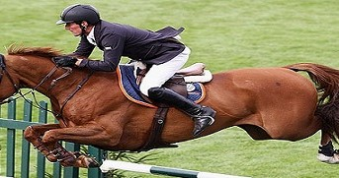
Movie buffs know of films like “National Velvet,” “The Black Stallion” and “Black Beauty.” Or you may have heard of films that tell how wild horses get tamed, like “Flicka” and “The Horse Whisperer.” The latter starred Robert Redford, who also appeared in “The Electric Horseman.” There have also been movies about famous horses, like “Seabiscuit,” “Phar Lap” and “Shergar.”
Racing aficionados are certainly familiar with horses that ruled the tracks. Aside from the aforementioned Phar Lap and Seabiscuit, we have had Citation, Red Rum, Secretariat, Seattle Slew, John Henry and Desert Orchid. And of course, there was Man o’ War, a horse so famous that he held his own during the roaring 20s when names like Babe Ruth, Jack Dempsey, Bobby Jones, Knute Rockne and the Four Horsemen of Notre Dame ruled the sporting world.
While Secretariat and Man o’ War may be the most famous horses ever, they are far from the most costly. Here is a list of the top 10 most expensive horses in the world.

10. Stay Thirsty – $500,000

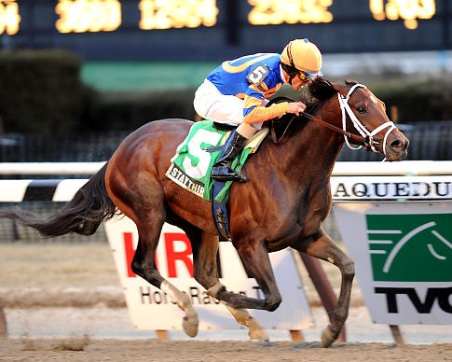
Stay Thirsty won five races and earned nearly $2 million in its racing career. Its pedigree line comes from Bernardini and Marozia. It is available for breeding for $20,000. Its price tag of $500,000 is a marked appreciation from the $160,000 paid for it by Glennwood Farm at the 2009 Keeneland when it was just a yearling. An agent offered half a million dolloars to Scanlon Training Center for the horse in 2010 at the Fasig Tipton Florida sale.

9. Lord Sinclair – $1.6 million

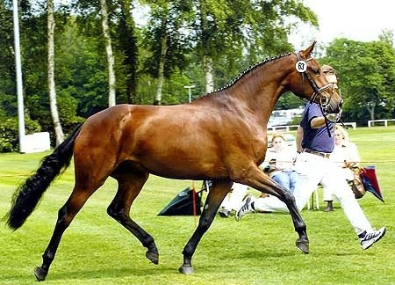
Lord Sinclair was a horse in Germany that qualified four times for the German Federal Championships. It won the German Young Horse Championship two times, was the principal premium winner of the Oldenburg Stallion Days and was the outstanding champion of the Stallion Performance Test of 1999. It was considered to be a high level dressage stallion. It has an overload of performance genes. Lord Sinclair has over 20 approved offspring, and they have been proving themselves by winning foal shows and championships. Lord Sinclair is known for its trademark noble and dancing movements.

8. Poetin – $3.3 million

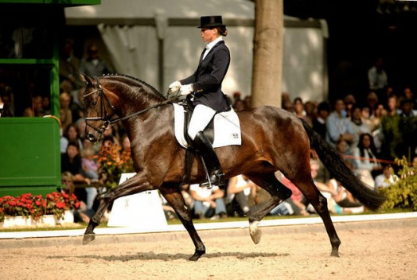
Poetin was a world class dressage horse. In 2003, it was adjudged to be the champion of the World Young Dressage Horse Championship. It comes from the line of Sandro Hit and Poesie, the 1999 World Dressage Horse Champion and the 2003 Hanoverian Stallion of the Year, respectively. Poetin’s first taste of success was in 2000 when it won the Bundeschampion while mounted by Heinz Heinrich Meyer zu Strohen. Her 2003 world championship was punctuated by a perfect score of 10 that the judges gave Poetin for her excellent trot.

7. Sardar – $3.5 million

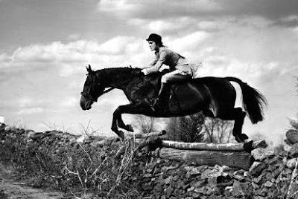
Sardar was a legendary racer famous for not just winning races but also for setting records. During its career, the horse was able to set a total of eight records that went unbroken for a long time. The horse was so popular that it once had an audience with then First Lady Jacqueline Bouvier Kennedy, the wife of the then-President of the United States John F. Kennedy.

6. Pine Chip – $4 million

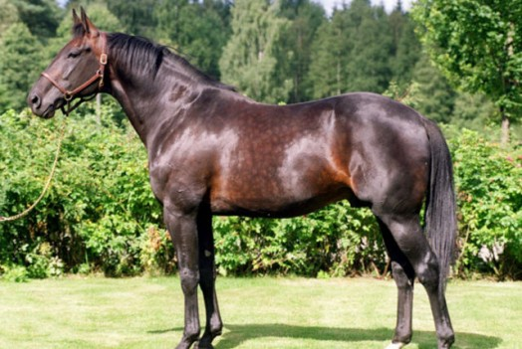
Pine Chip was an award-winning horse. At the age of three, it won a number of competitions, including the Historic Dickerson cup, Stanley Dancer Trot, Colonial Trot, Kentucky Futurity, American National, Transylvania Trot, Matron Stakes Final, World Trotting Derby and the Breeder’s Crown. The following year, it retained the Breeder’s Crown while annexing the Nat Ray Trot title as well.

5. Mystic Park – $5 million

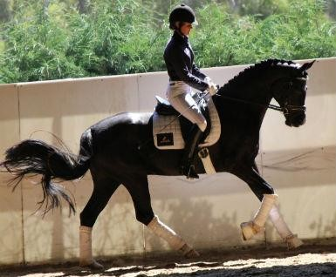
Mystic Park came from the line of Noble Gesture and Mystic Sign. At the age of three, it won a number of competitions, including the Dexter Cup, Historic Dickerson Cup and Yonkers Trot. In 1982, Lana Lobell bought it for a then-shocking amount of $5 million.

4. Seattle Dancer – $13.1 million

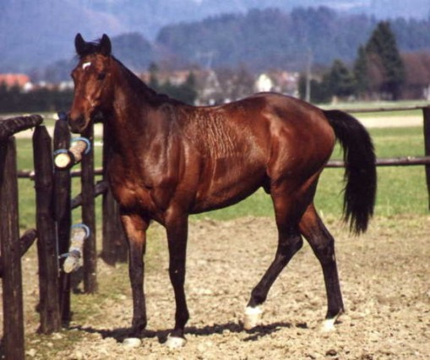
Seattle Dancer was probably the most expensive yearling ever sold at a public auction. The Irish thoroughbred came from a very impressive stock, including My Charmer, which was the dam Seattle Slew, the 1977 winner of the Triple Crown; Nijinsky, the 1971 winner of the British Triple Crown; and Northern Dancer, which the National Thoroughbred Racing Association cited as one of the most influential sires in thoroughbred history. Among his major wins were the Gallinule Stakes and the Derrinstown Stud Derby Trial, both in 1987. It then became a stud, serving in Kentucky, Ireland, Japan and Germany. It has sired 37 winners of various stakes.

3. Green Monkey – $16 million

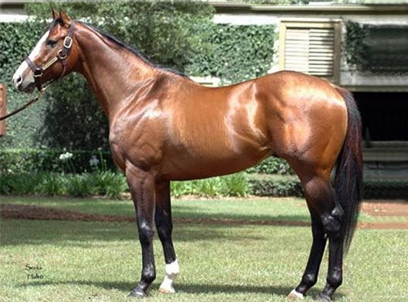
Green Monkey is an American thoroughbred that holds the world record price for a horse sold in an auction. It was bought during the Fasig Tipton Calder sale in 2006. Its line includes Forestry, Storm Cat, Magical Masquerade and Unbridled. Unfortunately for the new owners, Green Monkey proved to be a racing flop, racing only three times with a third place finish being its best performance. It earned just a little over $10,000. It is now available for breeding, with the owners charging a stud fee of only $5,000.

2. Annihilator – $19 million
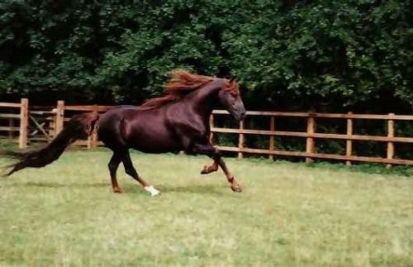
Annihilator came from the line of Niatross, the winner of the Little Brown Jug and the Meadowlands Pace in 1980, and Wish Me Wings. Annihilator was considered to be a very athletic horse that possessed a lot of pace, which a lot of racehorse owners value. It also made for a very good show horse because it had a beautiful dark chocolate mane.

1. Shareef Dancer – $40 million
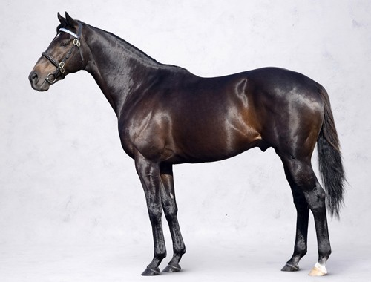
Shareef Dancer was an American-bred thoroughbred. It was stabled in the Godolphin Stables of Mohammed bin Rashid al Maktoum in England. Its impressive line included Northern Dancer and Sweet Alliance. It was entered into a race five times, winning three times and placing second once. Its most impressive wins were in the Irish Derby Stakes and the King Edward VII Stakes, both in 1983. It was also declared as the UK Middle Distance Horse of 1983. He is the damsire of Dubai Millenium.

